ASSIGNMENT -5.1
Name : ERUKULLA MAHANTH ARYA
HALL TICKET NO: - 2303A54028
BATCH 47A

Task Description #1 (Privacy in API Usage)
Task: Use an AI tool to generate a Python program that connects to a
weather API.
Expected Output:
• Original AI code (check if keys are hardcoded).
• Secure version using environment variables.
Prompt:
"Generate code to fetch weather data securely without exposing API keys”
SCREENSHOTS:-
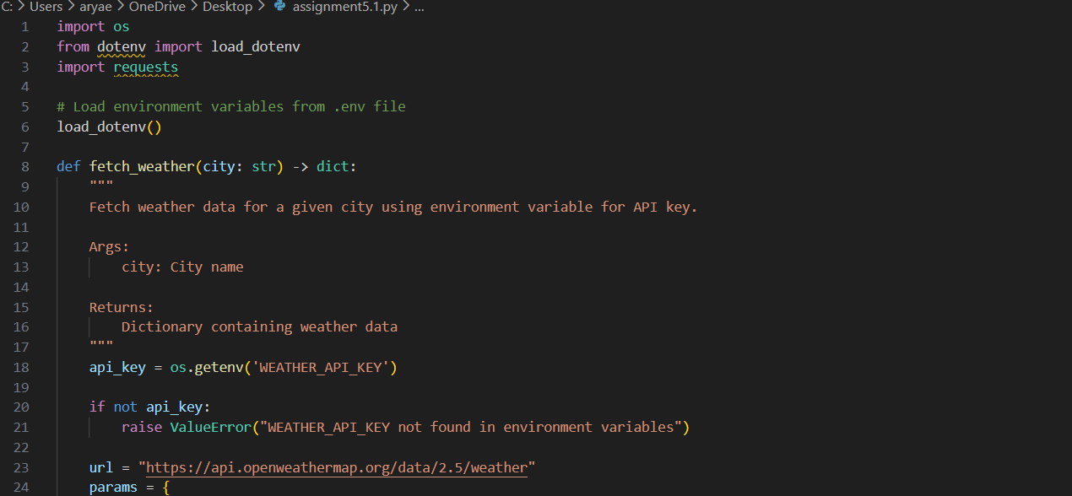
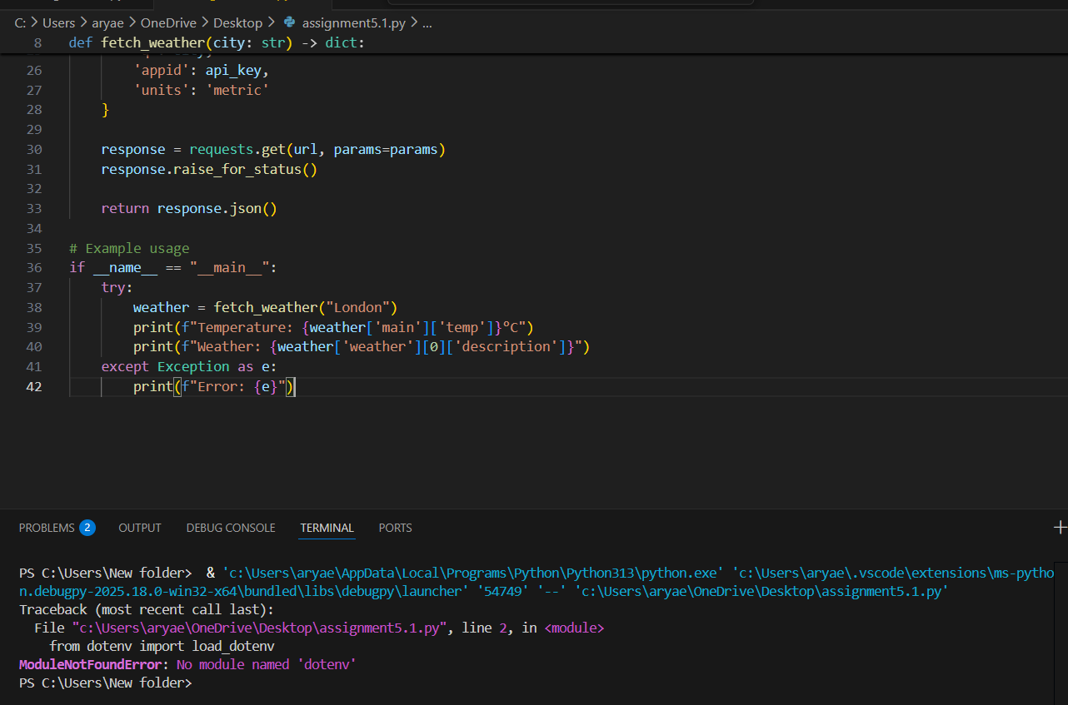
TASK -2
(Privacy & Security in File Handling)
Task: Use an AI tool to generate a Python script that stores user data
(name, email, password) in a file.
Analyze: Check if the AI stores sensitive data in plain text or without
encryption.
Expected Output:
• Identified privacy risks.
• Revised version with encrypted password storage (e.g., hashing).
PROMPT
Generate a Python script that stores user data (name, email, password) in a file.
Then analyze the script for privacy and security issues, specifically checking whether sensitive data (especially passwords) is stored in plain text or without protection.
Identify all privacy risks clearly.
Revise the script to follow security best practices by hashing the password before storage (do not store raw passwords)
SCREENSHOT ;-
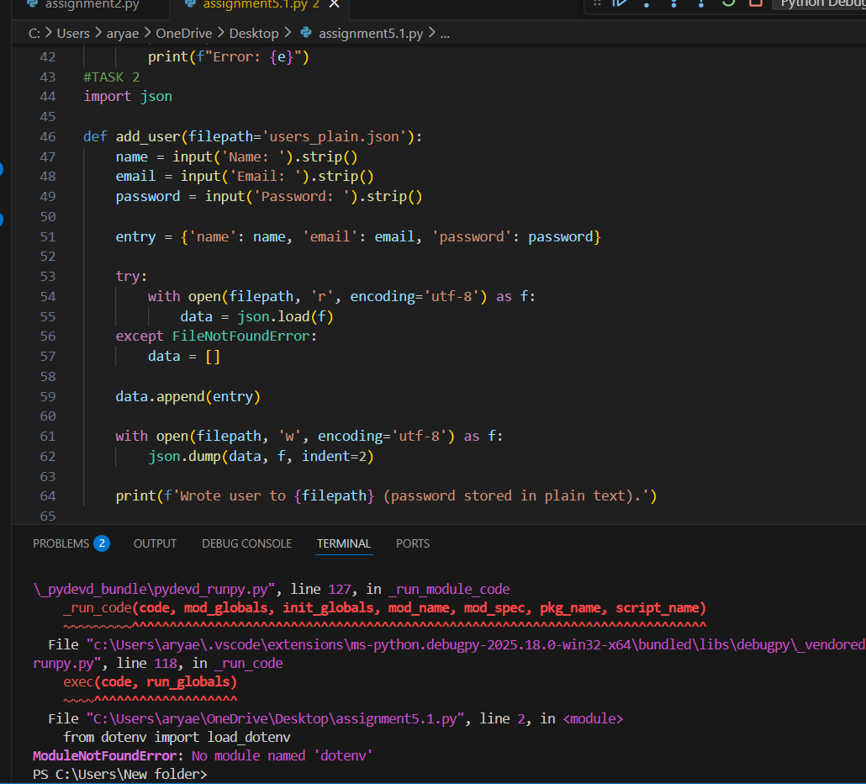

TASK -3
(Transparency in Algorithm Design)
Objective: Use AI to generate an Armstrong number checking function
with comments and explanations.
Instructions:
1. Ask AI to explain the code line-by-line.
2. Compare the explanation with code functionality.
Expected Output:
• Transparent, commented code.
• Correct, easy-to-understand explanation.
PROMPT ;-
Generate a Python function to check whether a number is an Armstrong number with clear comments, and explain the code line by line.
Ensure the explanation accurately matches the code’s logic and behavior.
CODE SCREENSHOT;-
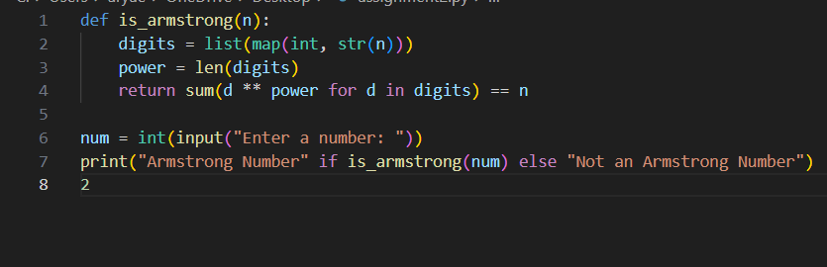
OUTPUT
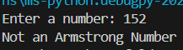
TASK -4
(Transparency in Algorithm Comparison)
Task: Use AI to implement two sorting algorithms (e.g., QuickSort and
BubbleSort).
Prompt:
"Generate Python code for QuickSort and BubbleSort, and include
comments explaining step-by-step how each works and where they differ."
Expected Output:
• Code for both algorithms.
• Transparent, comparative explanation of their logic and efficiency.
SCREENSHOT;-
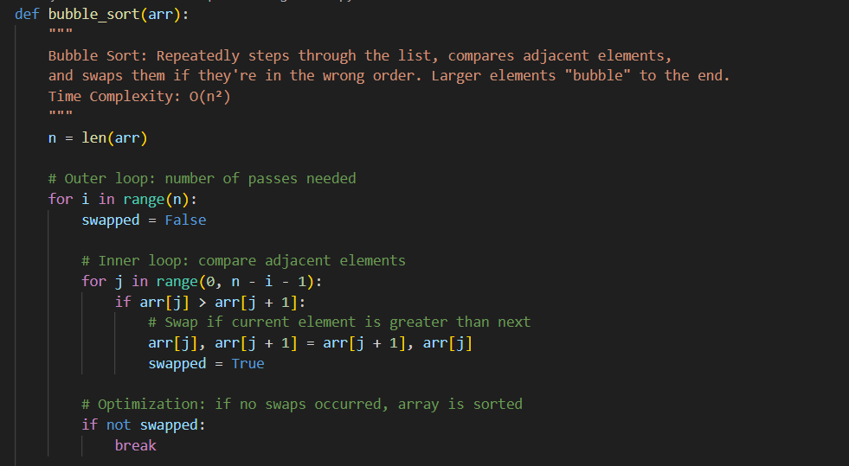
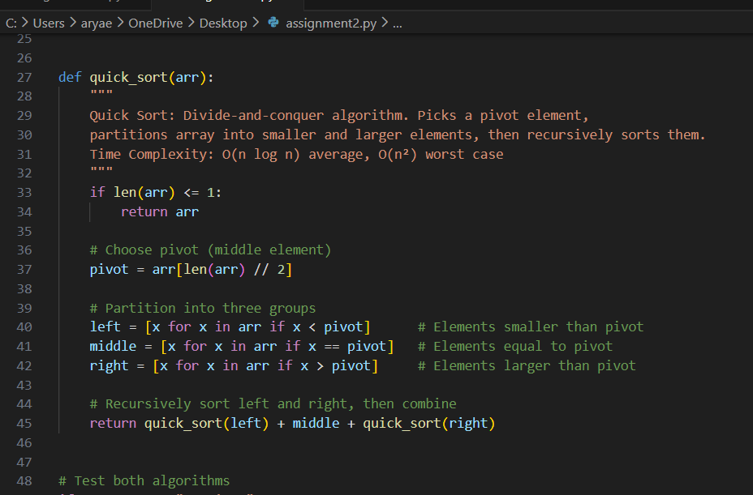
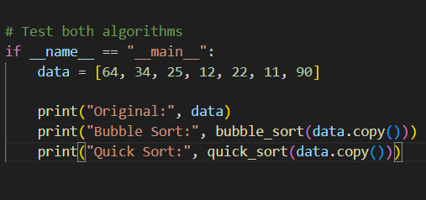
OUTPUT;-
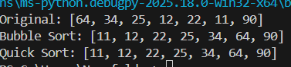

Task Description #5 (Transparency in AI Recommendations)
Task: Use AI to create a product recommendation system.
Prompt:
"Generate a recommendation system that also provides reasons for each
suggestion."
Expected Output:
• Code with explainable recommendations.
• Evaluation of whether explanations are understandable.
SCREENSHOT ;-
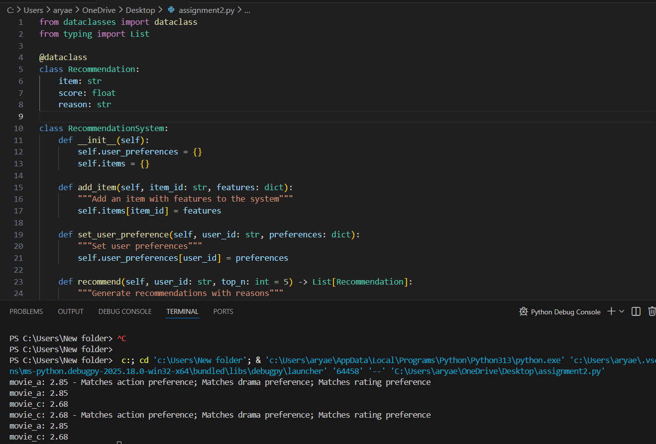
NOTE ;- In this above screenshot contain the code and output

